HARJOITUKSET – Tehtävä 4

Palauta word -dokumentti jossa kyselyt ja tulokset kuvakaappauksina tai terminaalista kopioituna Moodleen linkin kautta.

First be sure ae using right database –

write script use sql_kyselyt;

and then write show tables;

| Tables_in_sql_kyselyt |

+--------------------+

| countries |

| departments |

| employees |

| job_history |

| jobs |

| locations |

| regions |

+--------------------+

7 rows in set (0.00 sec)

So…we are ready to go challenges…
1. Write a SQL statement to create a simple table countries including columns country_id,country_name and region_id.
CREATE TABLE countries ( COUNTRY_ID varchar(2) NOT NULL, COUNTRY_NAME varchar(40), REGION_ID decimal(10,0), PRIMARY KEY (COUNTRY_ID));
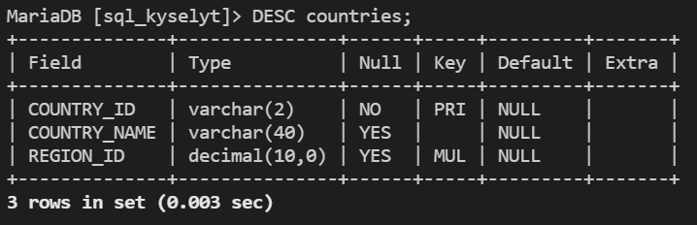
2. Write a SQL statement to create a simple table countries including columns country_id,country_name and region_id which is already exists.
CREATE TABLE IF NOT EXISTS countries ( COUNTRY_ID varchar(2) NOT NULL, COUNTRY_NAME varchar(40), REGION_ID decimal(10,0), PRIMARY KEY (COUNTRY_ID));
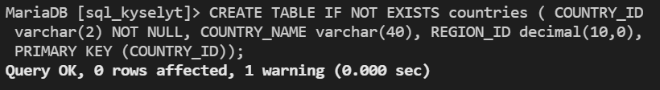
3. Write a SQL statement to create the structure of a table dup_countries similar to countries.
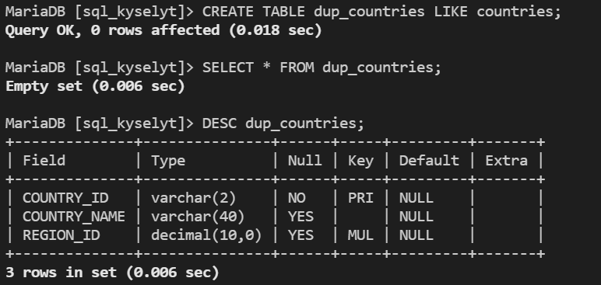
4. Write a SQL statement to create a duplicate copy of countries table including structure and data by name dup_countries.
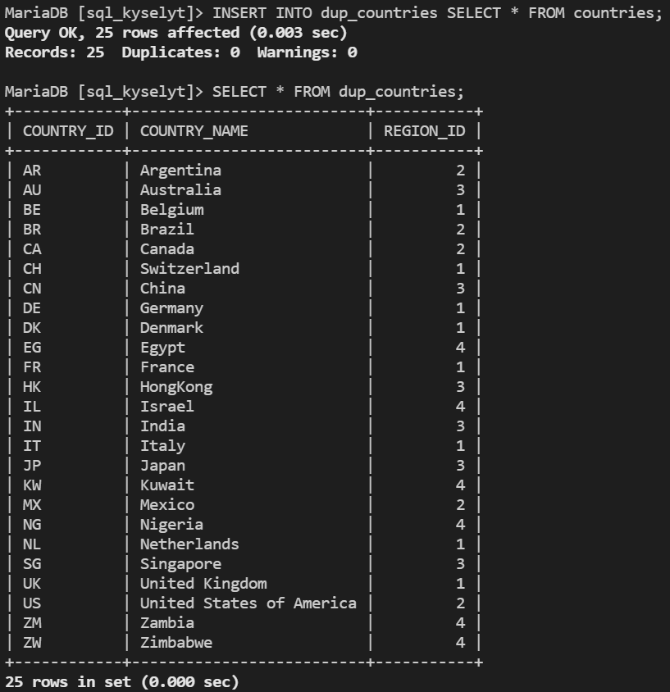
5. Write a SQL statement to create a table countries set a constraint NULL.
CREATE TABLE IF NOT EXISTS countries ( COUNTRY_ID varchar(2) NOT NULL, COUNTRY_NAME varchar(40) NULL , REGION_ID decimal(10,0), PRIMARY KEY (COUNTRY_ID));
6. Write a SQL statement to create a table named jobs including columns job_id, job_title, min_salary, max_salary and check whether the max_salary amount exceeding the upper limit 25000.
CREATE TABLE IF NOT EXISTS `jobs` (JOB_ID varchar(10) NOT NULL DEFAULT '', JOB_TITLE varchar(35) NOT NULL, MIN_SALARY decimal(6,0) DEFAULT NULL, MAX_SALARY decimal(6,0) DEFAULT NULL, PRIMARY KEY (`JOB_ID`));
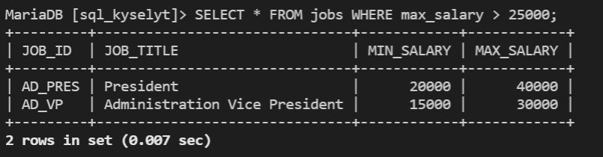

SELECT statement
7. Write a query to display the names (first_name, last_name) using alias name “First Name", "Last Name" Sample table: employees
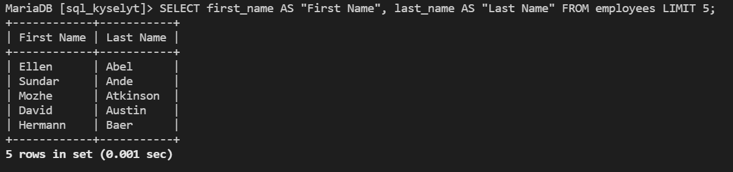
Put limit cause list is so long.
8. Write a query to get unique department ID from employee table. Sample table: employees
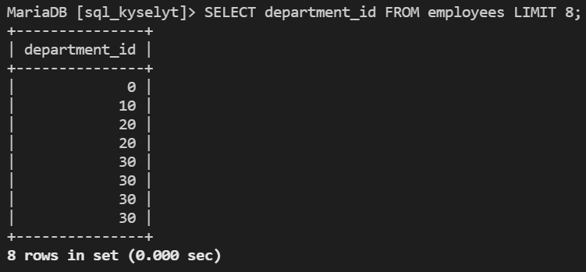
Put limit cause list is so long.
9. Write a query to get all employee details from the employee table order by first name, descending. Sample table: employees
SELECT * FROM employees ORDER BY first_name DESC;
10. Write a query to get the names (first_name, last_name), salary, PF of all the employees (PF is calculated as 12% of salary). Sample table: employees
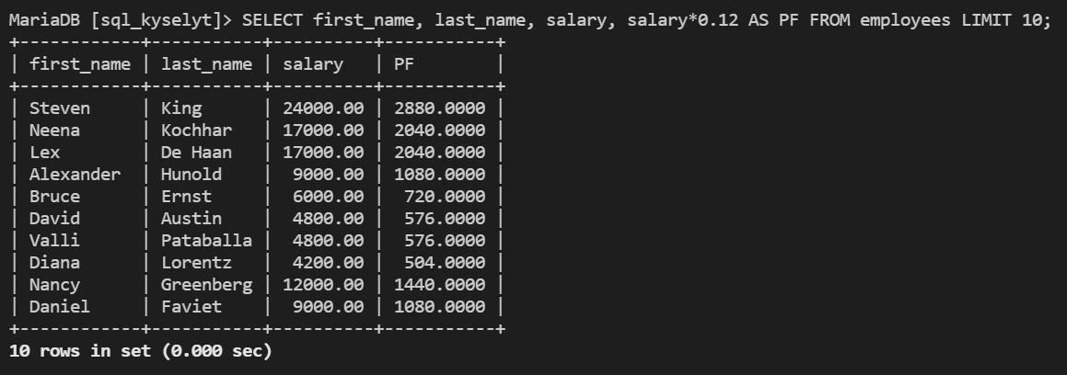
Put limit cause list is so long.
11. Write a query to get the employee ID, names (first_name, last_name), salary in ascending order of salary. Sample table: employees
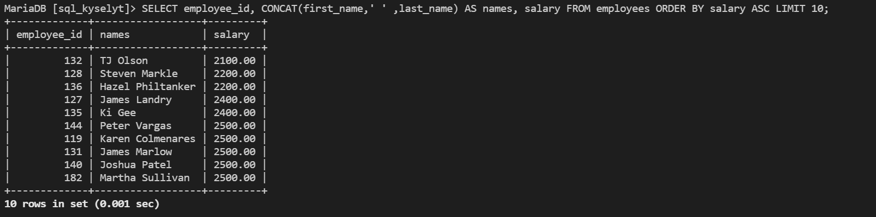
Put limit cause list is so long.
12. Write a query to get the total salaries payable to employees.Sample table: employees
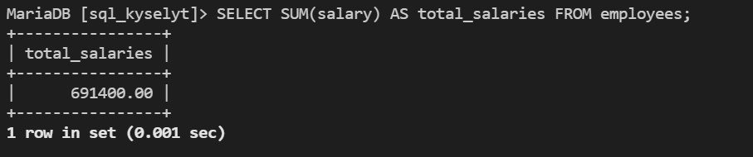
13. Write a query to get the maximum and minimum salary from employees table. Sample table: employees
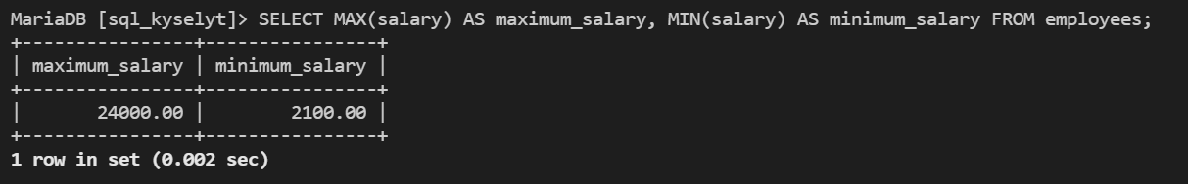
14. Write a query to get the average salary and number of employees in the employees table. Sample table: employees
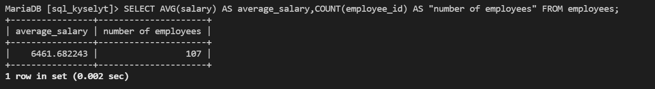
15. Write a query to get the number of employees working with the company. Sample table: employees
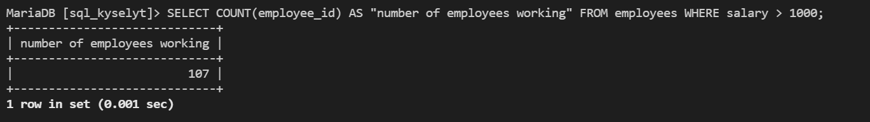
16. Write a query to get the number of jobs available in the employees table.
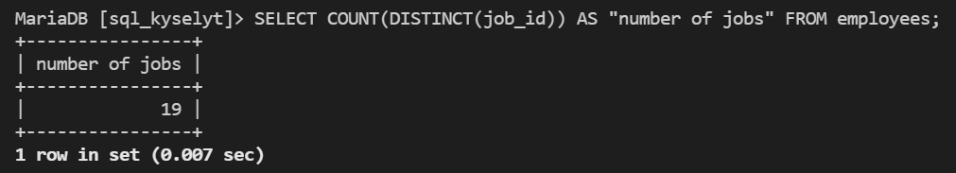
17. Write a query to get monthly salary (round 2 decimal places) of each and every employee. Note : Assume the salary field provides the 'annual salary' information
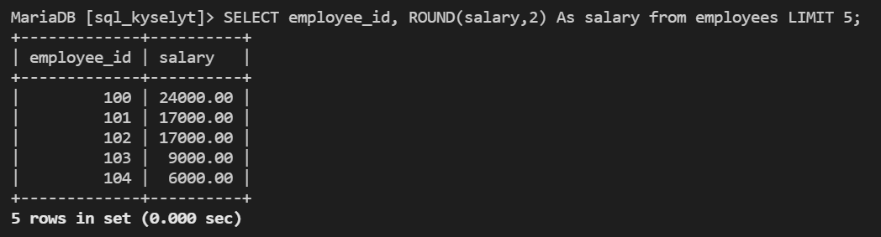
18. Write a SQL statement to change salary of employee to 8000 whose ID is 105, if the existing salary is less than 5000. Sample table: employees . Hint. Use Update!


